/FOR SIZE AND ALIGNMENT SEE OVERVIEW. FOR IMAGES ACCES FOLDER. THIS IS FOR CONTENT ONLY/

**Preview**

**Video**

a Time Use Data collection tool that is context aware, effortless for the respondent and saves data in a research-convenient format. Samay Lekha is a smartphone application which attempts to enable entering data as easy as any daily routine for the respondent.

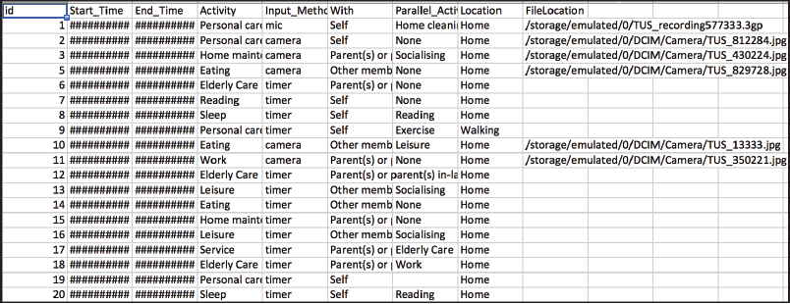

Researcher gets a datasheet from each respondent - in the Time Diary Format

Download app from [here](https://drive.google.com/open?id=0BwOkpT7FG0DLZkhlcVVaNF8tckE)

**Webpage**

Time use studies rely on either participants keeping track of their activities or data collectors observing and interviewing participants. This is effort intensive relative to the quality of data thus collected.

In this project, I attempt to create a Time Use Data collection tool that is context aware, effortless for the respondent and saves data in a research-convenient format. Samay Lekha is a smartphone application which attempts to enable entering data as easy as any daily routine for the respondent.

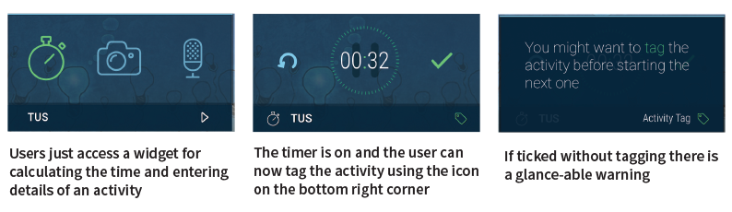

On clicking tags icon from the main widget or from the warning screen gives a drop down list of activities. The activities are based on the proposed list from secondary research.

Activity Tags

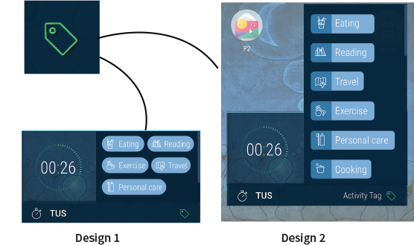

On clicking tags icon from the main widget or from the warning screen gives a drop down list of activities. The activities are based on the proposed list from secondary research.

Input Methods

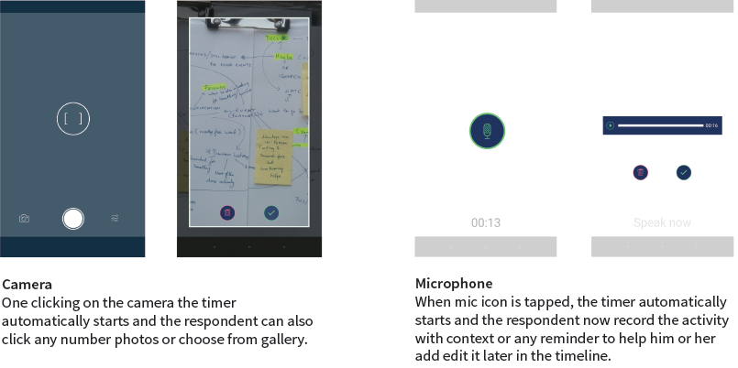

Timeline

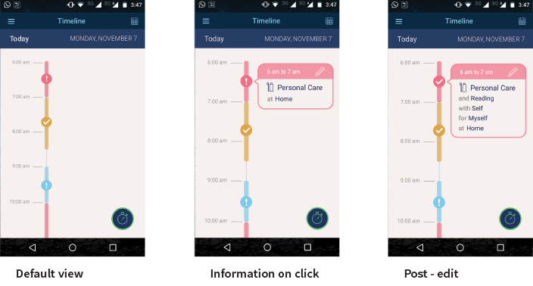

Exclamation means the activity is not completed on the timeline. Still some editing is required which means not all fields are completed but some marker is added. On tapping the Exclamation, the user gets to edit the activity to update it.

Edit Screen

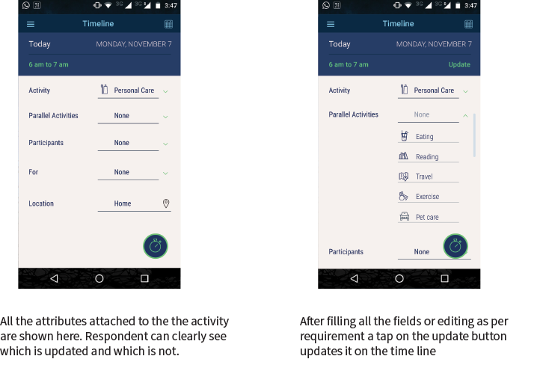

Database



The data gets saved in the database and the details are in a simple format based on the tags. This can be easily viewed and sent to the researcher. The option to extract this is available in the burger button from the app.

Design Timeline

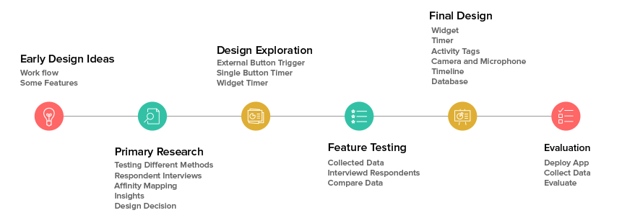

Primary Research

A total of 12 Respondents recorded data for 48 hours and were free to choose the method as per their convenience and the data were entered every time an activity was performed.

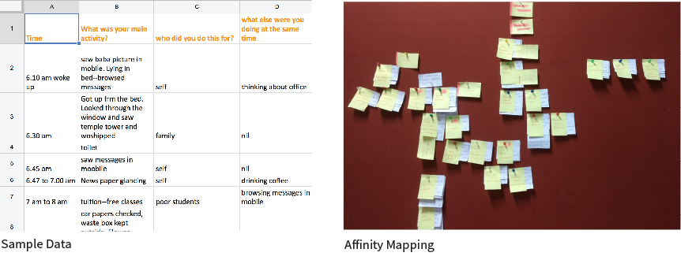

Concept Model

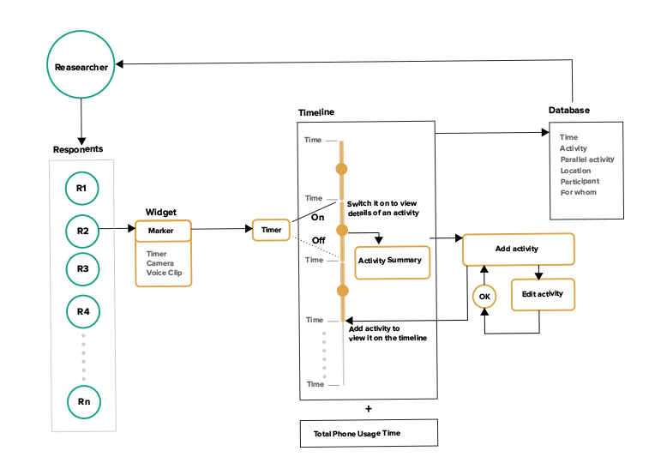

Scenario

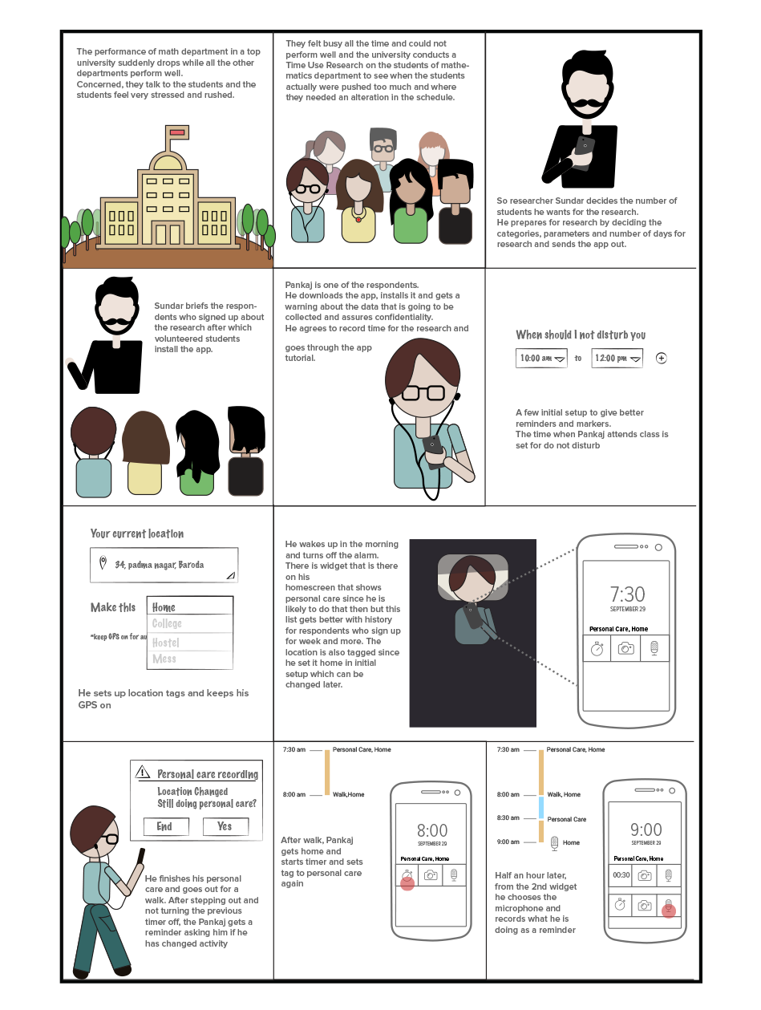

Feature Testing

In order to make this effort intensive process of data entry seamless with the daily routine of respondents, the design decision of Samay Lekha has a lot of features. There are multiple input methods for recording time, which was based on Respondent interviews.

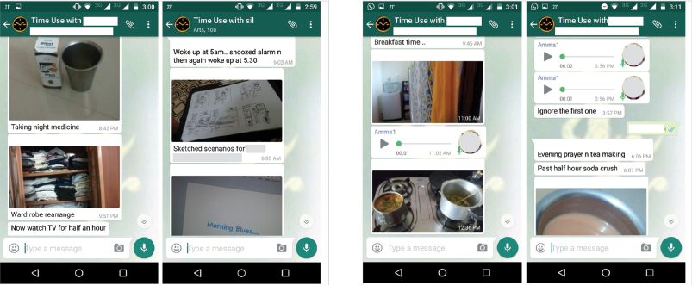

Whatsapp groups were made with each respondent and they could send voice recording, picture of their activity or type the details as they wished

Evaluation

Using the prototype an evaluation was done with think aloud test and a form was filled with interviews later. Two tasks of recording time with camera and microphone were given in think aloud test. Later they were asked to use the application for 24 hours

Report

Download Report from this [link](https://drive.google.com/drive/folders/0B372owFok6P-Zmc0U3F5dGxhUzA)

Acknowledgement

Thank you Dhiraj to help me develop the application